8th November 2021
Dear Parents and Carers

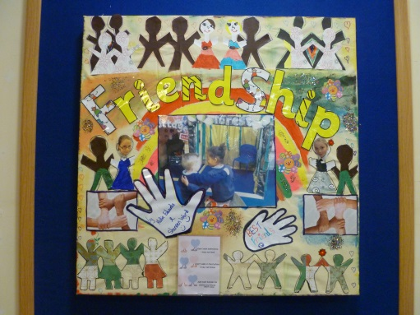
Thank you for all your support with our value for autumn first half term which was Respect. Throughout September and October, children learnt the importance of being respectful towards all individuals by treating them equally and looking after people, animals, the environment and property. We also discussed the importance of having good manners and showing gratitude to others.

Our ‘A Valued Me’ core value for the second half of our autumn term is Friendship.
Friendship is an act of giving to others.

Ideas for the theme of Friendship are –
- Discuss ‘What is a Friend?’
- Talk about how we can care for our friends.
- Get your child to draw a picture of a special friend and write why they like them.
- Discuss ‘The only way to find a friend is to be one’.
- Talk about being a good friend and get your child to think about what kind of friend they are. How does being a friend influence their behaviour?
- Get your child to make two lists-
      - What have you done this week that was friendly to others?
      - What have you done this week that was unfriendly to others?
- Discuss what they write and give positive praise and encouragement for friendly behaviour.
- Talk about what makes a good friend – this can be to brothers and sisters too!
- Complete each of these with as many answers as possible:
      - I’ll try to be a good friend by…..
      - What I like about my friends is ….

Thank you for your continued support.

Yours sincerely

Mrs Cartwright
Deputy Headteacher

